# C Project Report:

# The Management System for Student Organizations

**Group 15**

TU YUAN

FU XINYU

YU CHENXI

## Abstract

Clubs and student organizations are very common in the university, and joining those organizations or clubs could be a problem because the difficulties of finding the exact one you like. Management system is very popular in nearly all kinds of area since it is really useful and convenient. However, little work has been done on using management system to solve the problems of student organizations recruiting new members.

Attaching importance to this real problem, our group attempt to build a system both for JLU students and student organizations.

In our system programming, we pay attention to some core needs of the users. The very first one is, our system can help both the students and the organizers.

For the students, they can search for all the clubs and organizations that published the recruiting information, and choose a specific one he or she wanted to join. After applying for the club or organization and taking part in the interview or the writing test, the student can later find his or her grade and whether his or her application is permitted.

For the organizers, they can publish their ads and basic information about that recruiting activity via this system. Besides, they are able to receive the applications that submitted by the students. Last but not least, the organizers can also publish the recruiting result on the system.

In short, this system provide a chance for the smooth progress of the recruiting activities, and a systematic source of information for JLU students when facing the difficulty of choosing clubs.

## Introduction & Problem Statement

Students organizations is very common among today’s campus. Joining a student organization, you can not only improve your ability to work and socialize, but also make a lot of good friends. In Jilin University, hundreds of clubs and three main student organizations formed the lively part of JULer’s free time. Actually, in every April, student organizations meets the time for recruiting new members and student (usually fresh man)can choose one or more clubs they like to join in. However, there some problems and shortages in current ways of recruiting.

Nowadays, student organizations in JLU usually use following 3 measures to recruit their new member: hanging out the posters, making lectures in classrooms and posting ads on wechat public account. They do not have a unified way to publish these information.

It is the same for students. Posters hang all over the campus and it is not possible for one to find all of them. Lectures are only given is some classroom and you may have a time or location conflict with the lecture. Not all people follows the public accounts of the club or organization, and not everyone has a friend who pay attention to these information. In short, it is likely for students to miss these recruiting information.

As a result, we developed this recruiting system to help both the organizer and the students to find find their favorite member/club, and we sincerely hope that JLUers can have a fantastic college life.

·2. Group members and Division of labor

|  |  |  |  |
| --- | --- | --- | --- |
| Name | student ID | College | Grade |
| Tu Yuan | 12180610 | Chemistry | 2018 |
| Fu Xinyu | 13170624 | Biology | 2017 |
| Yu Chenxi | 13170317 | Biology | 2017 |

### Tu Yuan

Tu yuan mainly takes charge of making the welcome interface and menu part, and integrated the codes together. Besides, she also fix some of the bugs and modified some incompatible parts. She also helped to revise the activity part.

### Fu Xinyu

Fu Xinyu mainly takes charge of the register part, log in part and export part. What’s more, he made most of the flow charts for our presentations and final project report. He also helps to revise the activity part.

### Yu Chenxi

At first, Yu Chenxi came up with the idea of this program and wrote the program planning proposal. She also made grade submitting part and the first version of activity part , and revise the menu part. Besides, she mainly took charge of making PPT and writing final project report.

## 3. Analysis

After realizing this question, we analyse the demands of JLU students.

To begin with, to make sure that the user is a member of JiLin University, the register part and log in part is necessary. Student’s user’s name and password can be given in advance, and when using this system, they can fill in their basic information and log in this system.

Besides, since recruiting new members is a very comprehensive process, our system should meet with the demand both from the students and the organizer. As for system development and maintenance staffs, they also need to sort out all these information. Based on the above considerations, our system should have three different entrance respectively for students, organizers and staffs. The detailed demands from these three aspects will be listed a s follows.

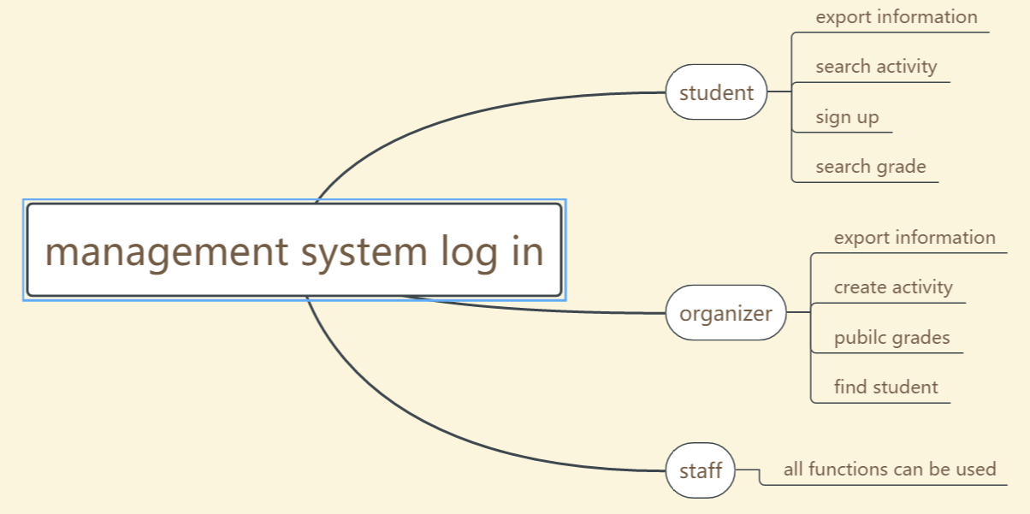

Figure 3-1

For students, firstly they should know all the recruiting information from all the student organizations. They should have access to know all the clubs and student organizations that want new member and their recruiting details. By scanning these information, students can find the club they like.

Secondly, if they want to find a specific recruiting activity or a organizer, they can search the name for a certain activity. If the name they want matched with the activity that already have, then students can get the detailed information of the activity.

Thirdly, signing up on this system could be much more convenient than fill in the paper application and hand them in to a remote place, so the sign up function is necessary. By simply typing their information on our system, student can let the organizer know their desire of joining these club.

Last but not least, if the organization’s recruiting process needs some small test, students needs to know the result of the test. By input their own name, students can got their grades.

Standing at the organizers’ perspective, other functions are needed. Firstly, if an organization wants to recruit new members, they need to publish the activity notice. They should create an activity on the system and fill in essential information about the activity, and save it into our system.

Secondly, the organizer need to have a look at how many application they received. When student submitted their application, files are stored in our system. The organizer needs to print out all these applications and made further arrangements such as booking free classroom for making tests or interviews, and purchasing essential items for recruiting.

Thirdly, if the organizer is curious about whether a specific student applied for this activity, they can input the name of the student and got the result.

Finally, if the organizer want to test the students, a small test is need, and when finishing the test, organizers can submit the grades and scores via these system.

For the system development and maintenance staffs, they can have the access to all these functions.

## Design

* The overall description of the system

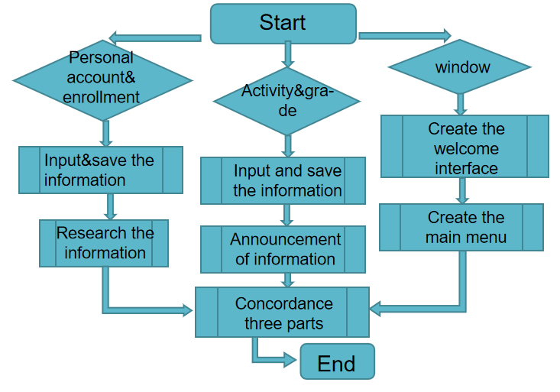

Figure 4-1

In the login part,users must create their new ID and password ,then the system will save the information.And when users input both the ID anf password right,the system will login in perfectly,or it will tell that your password is wrong and users should input the correct password.

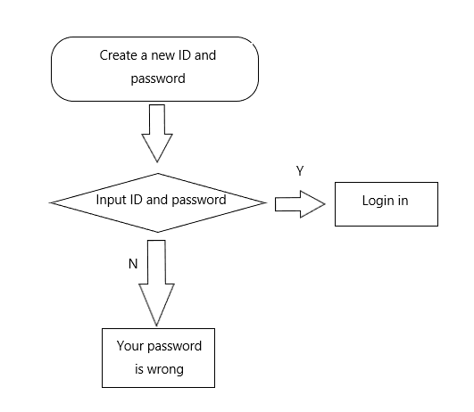

Figure 4-2

In the enrollment part ,users should input their own information ahout the enrllment ,then the system can save the information. And when users want to search ,they only should input some keyword about the enrollment ,then system can show the information.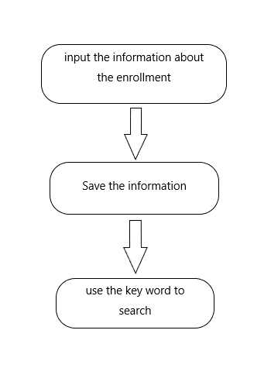



Figure 4-3

* The interface for inputing your choice

To fulfill the operation function of our systtem, an intreface is necessary. At the beginning we want to use the window function or EasyX to achieve this pary, however, those two function both have some shortage and couldn’t match our system well. As a result, we choose to use the keyboard and press the keys to operate the system. A number repersents a function and by doing this, the users can inter the coresponding interface. 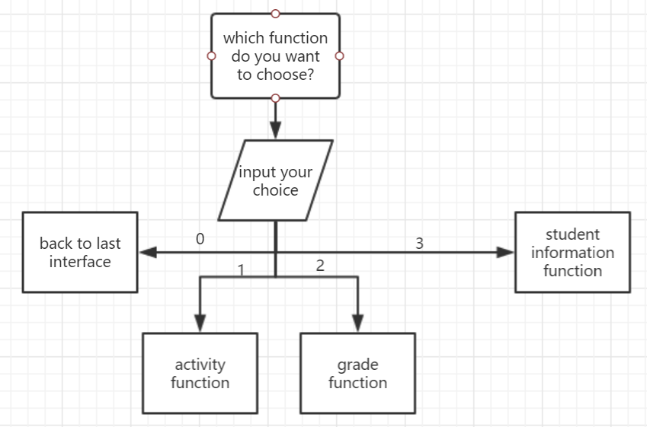

* The export function

The export is to read the information from the file and print them out. If the file can not open correctly, the function will end at the reading point. If the file can open correctly, the system can read the information from the file and print them out.

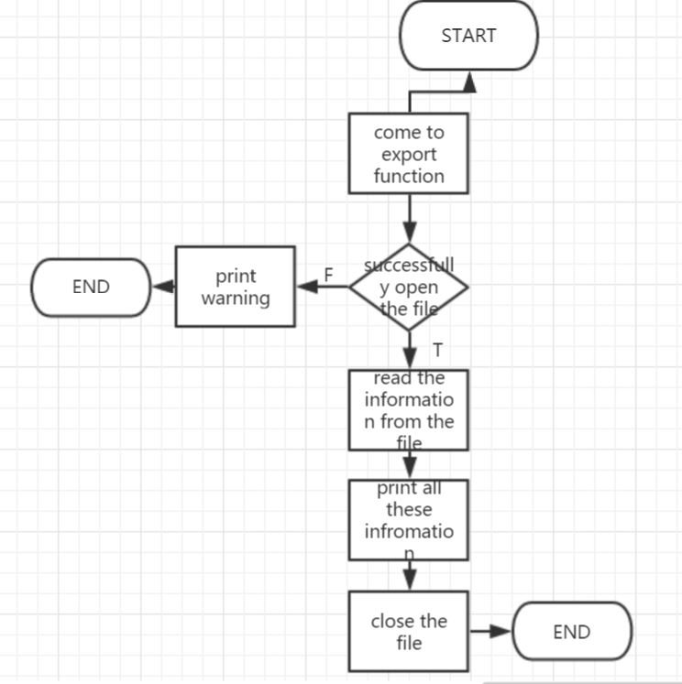

The other part of our system is a bit similar as the function we describe above in the logic aspect, the difference between them will be described below in the implementation part.

* **5.Implementation**

1. **Welcome interface and menu part**

**To add the picture as our welcome interface, we invoke a graphics library called graphics.h. We use initgraph to prepare for the image and set the pixel of the picture. Use loadimage to load the image and use putimage to print the image at the specific place.**

void welcome()//菜单

{

initgraph(323, 202);

IMAGE img; //准备图片

loadimage(&img, "D:\\ConsoleApplication1\\背景.jpg");

//加载图片 L"背景.jpg"是图片的相对路径,也可以使用绝对路径

putimage(0, 0, &img);

//在指定位置贴图 前面的(0,0)是坐标 后面的&img是要贴的图片

_getch();

closegraph();

}

**In the menu part, firstly we introduce op as the operating way and loop as the sign of looping. The system imply you of the number and the corresponding choice, and the goes into switch function. When input the number you choose, the case function with lead to a function that we created before, and then break the cycle. If we choose the number zero, zero was assigned to loop and the cycle is break.**

**The following the our codes.**

void menu1()

{

int op; // 操作方式

int loop = 1; // 是否循环

while (loop)

{

system("cls");

printf("\n===================== Activity Registration System =====================\n");

printf("\n0:Sign out \n\t1:Enter registration information \n\t2:Enquiry for registration information \n\t3:Export registration information\n");

printf("\nPlease enter your choice：");

scanf_s("%d", &op);

getchar();

switch (op)

{

case 0: // 退出

loop = 0;

break;

case 1: // 录入信息

entering();

break;

case 2: // 查询

query();

break;

case 3: // 导出

export();

break;

default: break;

}

printf("\n \

Thank you for usage,the system has exited\n");

system("cls");

}

}

1. **Register part and log in part**

**To save the register information, firstly we opened a txt file called web1, and save the register ID and code into this file. If the file can not successfully open, then the system will print “So sorry that the system can not link to the server.” . We use cin.get() to eat to empty character, and use getline to avoid of setting too long or too short name or codes.**

**The following codes is for register part.**

void Register()

{

ofstream outFile;

outFile.open("web1.txt", ios_base::out | ios_base::app);

if (!outFile.is_open())

{

cout << "很遗憾，连接不上服务器";

cout << "程序结束";

cin.get();

exit(EXIT_FAILURE);

}

string name;

string code;

cout << "Please Enter members name: ";

cin.get();

getline(cin, name);

outFile << name << endl;

cout << "Please Enter members code: ";

getline(cin, code);

outFile << code << endl;

cout << "注册成功！";

outFile.close();

Display();

}

**We create the enter function to identify whether the user is a JLU student or organizer. Firstly we use ifstream inFile to define ifstream object, and read the register information from web1.txt file. Then you put in your user’s name and the system will find the same name from the file using getline function. If successfully matched, then the code inputting reminder will appear. Again, the system will match the code from the file using getline function. If the code is successfully matched, the system will skip to the main menu part.**

**The following codes is for log in part.**

void Enter()

{

cin.get();

ifstream inFile;

inFile.open("web1.txt");

if (!inFile.is_open())

{

cout << "很遗憾，连接不上服务器";

exit(EXIT_FAILURE);

}

string name;

string code;

string temp;

cout << "Please Enter members name: ";

getline(cin, name);

while (getline(inFile, temp))

{

if (temp == name)

{

cout << "Please Enter members code: ";

getline(cin, code);

getline(inFile, temp);

if (temp == code)

{

cout << "登录成功";

menu_main();；

}

else

{

cout << "密码错误";

Display();

}

}

}

}

1. **How you can submit/find/export the grade and student information:**

**We define the function inputStr and inputNum in advance to avoid of the complexity and repetition of our code. When entering this interface, firstly we use system("cls") to clear the interface. Then a for cycle is used for continuing input the information. Once a single turn is done, the system will ask you whether you want to continue, and an if function is used to judge your choice and continue or end the for cycle.**

**And the following is our code for the implement.**

// 输入字符串

void inputStr(char * c, char * tips)

{

printf("please enter%s:", tips);

gets_s(c, sizeof(c));

}

// 输入数字

void inputNum(int * n, char * tips)

{

printf("please enter%s:", tips);

scanf_s("%d", n);

getchar();

}

// 录入函数

void entering()

{

system("cls");

int i;

for (i = 0; i < N; ++i)

{

printf("\n\n---------(input registration) %d (information)---------\n\n", i + 1);

inputStr(S[i].name, "name");

inputStr(S[i].gender, "gender");

inputNum(&(S[i].age), "age");

inputStr(S[i].place, "native place");

inputStr(S[i].number, "student ID");

inputStr(S[i].class, "class");

inputStr(S[i].department, "major");

printf("Do you want to continue?( 1 for YES and 2 for NO)\n");

rewind(stdin);

scanf_s("%d", &j);getchar();

if (j == 2)

break;

}

}

**In the query part, the principle is quit similar with the submit part. What the query part adds is a strcmp function, which can be used to find the same information as you input in the system and define whether you can inter the if function.**

if (strcmp(number, S[i].number) == 0)

{

printf("\n--------(registration information)--------\n");

outputStr(G[i].name, "(name)");

outputStr(G[i].gender, "(gender)");

outputNum((G[i].age), "(age)");

outputStr(G[i].number, "(student ID)");

outputStr(G[i].class, "（class）");

outputStr(G[i].department, "（major）");

outputStr(G[i].grade, "(grade)");

printf("\n------------------------\n");

}

**In export part, we use fopen_s and fclose to invoke the information from the file.**

void export_grade()

{

FILE *f;

int i;

fopen_s(&f, "export.txt", "w");

printf("\n-------------------------\nIn the process of derivation...\n");

……

fclose(f);

}

* **6.Testing&Debuging**

If everything is ok, we will be able to use all the function of the system. But we found some bugs in our system.

1. The welcome picture cover the words.

|  |  |  |
| --- | --- | --- |
| Situation | Expect result | Real result |
| We you click the system,  the welcome picture don’t link with the founction part and it will cover the next window | After your start the system,the founction windows can appear after several seconds automaticly. | The window is fixed on the welcome window and can’t move to the next part |

We try to use all windows on the picture we chose, but later we found the picture will cover all words and it is unexpected to display the system on one picture. Therefore, we use clear founction to clear the welcome picture in time to show the next operation. We also add founction to link the next operation after user press the key the system remind.

1. the activity system don’t return in time.

|  |  |  |
| --- | --- | --- |
| Situation | Expect result | Real result |
| In the activity realease part, debug the founction of creating an activity and realease it. | We hope the number of activities be created by users can be decided by user. | When you choose to create activities, the system won’t stop the create windows , it will stop in this step and can’t return the last or next step. |

At first, we don’t konw how to stop the founction of creating activities and cover the need of the user. We find other examples of system and try to create a link to continue to next step. We change the judge of the number of people in need. If the user input zero in the number, the system will return to the menu and execute the next order. To remind our users, we also set a words about how to stop creating on the activity creating window.

After solve the problems, we test the system.

|  |  |  |
| --- | --- | --- |
| Meun1 |  | |
| 1,sign out | You will log out and the system will close. | |
| 2,activity registration | You will choose to enter, enquiry or export the registration information. | |
| 3,log in and register | You will choose to enter, register or exit your own student account. | |
| 4,activities realease | students | Register, or enter the activity part. |
| managers | Realease the information of activities or enquiry the information of all activities exited. |

It is a system with different founctions. After our test, mainly founctions of it is able to use. We hope to improve it to much better.

**7.Result & Conclusion**

Over a period of more than three months, all of our members have spent a lot on projects. We made progress together and learned together. At the time we deciside which project should we do, we did not have the concept of how to use C langeage to make a game or a system. Everything seems impossible. On a Sunday evening we made the division of our work and worte the outline of our project. Every weekend we analyse our projecy and try to write the code. When facing some difficulity, we searched on the internet and learn to solve the problem.

Drawing flow chart, making PPT and writing program report iare also reat chanllenges. It is our first time the making preserentation in English and writing such a long file in English. We stayed up late and devoted every effort to make our preject better.

Through this percious training, not only we improve our C language level, but also our English level, the ability of giving speech, and our coorperative ability. We sincerely appreciate the experience and this way of giving C language class.